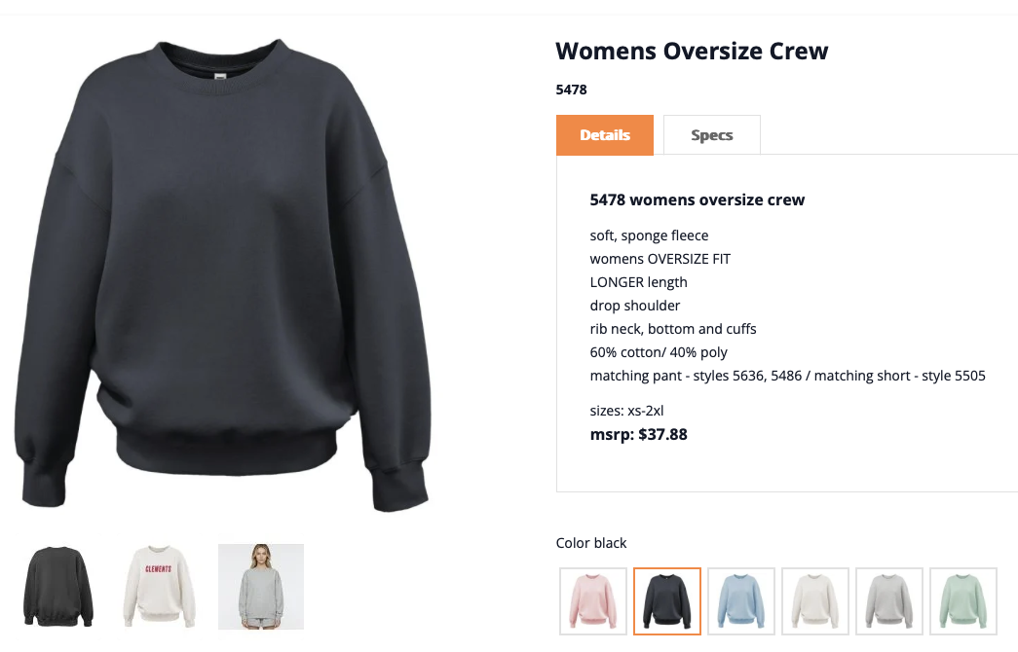 https://www.pennantsportswear.com/womens-oversize-crew-5478.html
Small logo centered chest (like where comfrt logos are on their sweatshirts)
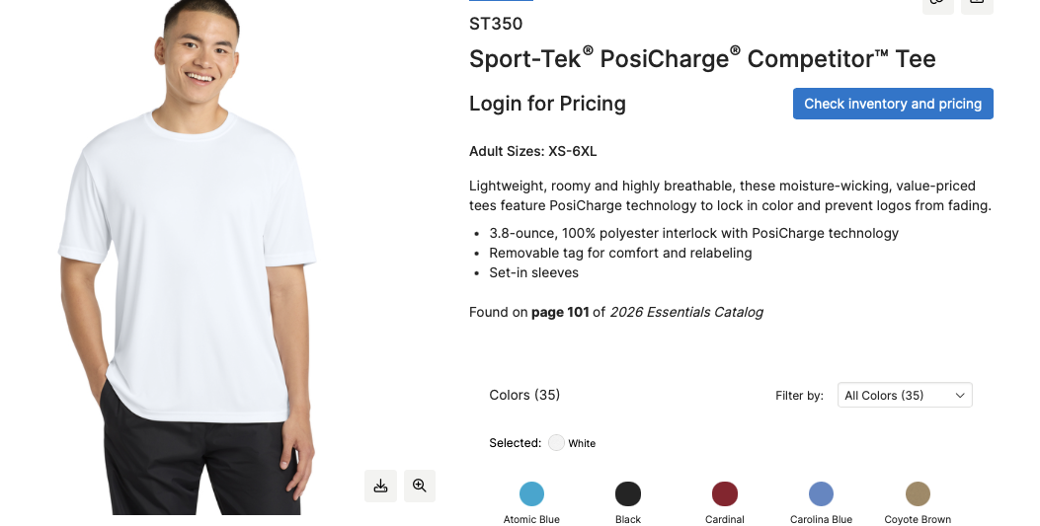
https://www.sanmar.com/p/4349_White

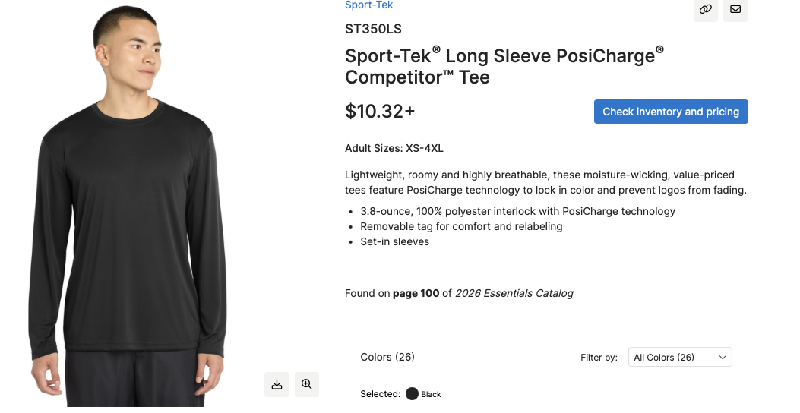
https://www.sanmar.com/p/4352_Black

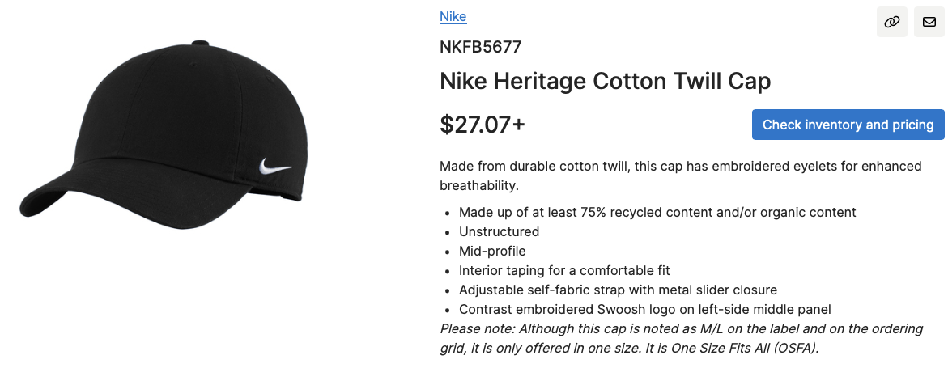 https://www.sanmar.com/p/31911_Black
Just the max field hockey logo centered on front

